**INFO6205: Program Structure and Algorithms**

**Assignment 5 – Minimum Spanning Tree**

**By**

**Ajay Mohandas**

**NEU ID: 001426741**

Contents

Introduction 2

Problem Statement 2

Observation 2

Analysis 2

Screenshot 2

Conclusion 5

# Introduction

A minimum spanning tree (MST) or minimum weight spanning tree is a subset of the edges of a connected, edge-weighted undirected graph that connects all the vertices together, without any cycles and with the minimum possible total edge weight. That is, it is a spanning tree whose sum of edge weights is as small as possible.

# Problem Statement

Find lowest cost to connect all buildings from a list with tunnels

# Observation

1. Kruskal algorithm helps in finding an edge of at least minimum possible weight to connect two trees in a forest.
2. This algorithm connects two buildings via tunnels and cost of constructing that tunnel is given
3. Here we are considering the length of tunnel is proportional to cost of each constructing that tunnel
4. Constructing tunnel between two buildings will bear a cost and we have to make sure to connect all building with minimum cost by making sure that we don’t form a cycle
5. The output gives a list of Buildings and put the list in a hashmap
6. After displaying the list, we get a report of two building connected with cost of constructing that tunnel
7. The end result gives a minimum total cost of constructing the tunnel and length of tunnel

# Analysis

1. Union find algorithm is used to check if two building is connected or not, if not connected then connect them else ignore it and find the weight to connect them
2. With this approach we can make sure each and every building is connected from the list
3. There are only 80 indexes to be marked for connection two buildings
4. The sum of cost of constructing each tunnel is summed up to get the total cost and also the total length

# Screenshot

KruskalTest.java

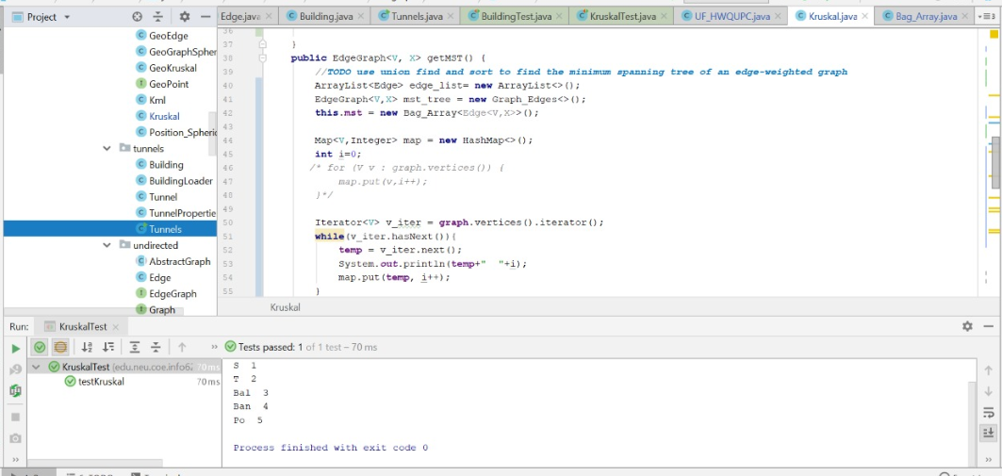

BuildingTest.java

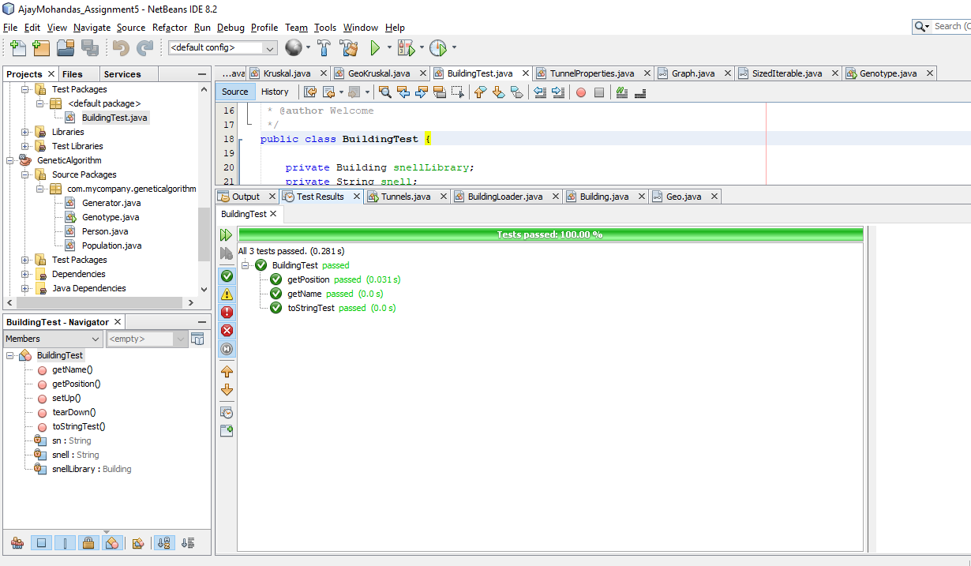

Tunnles.java

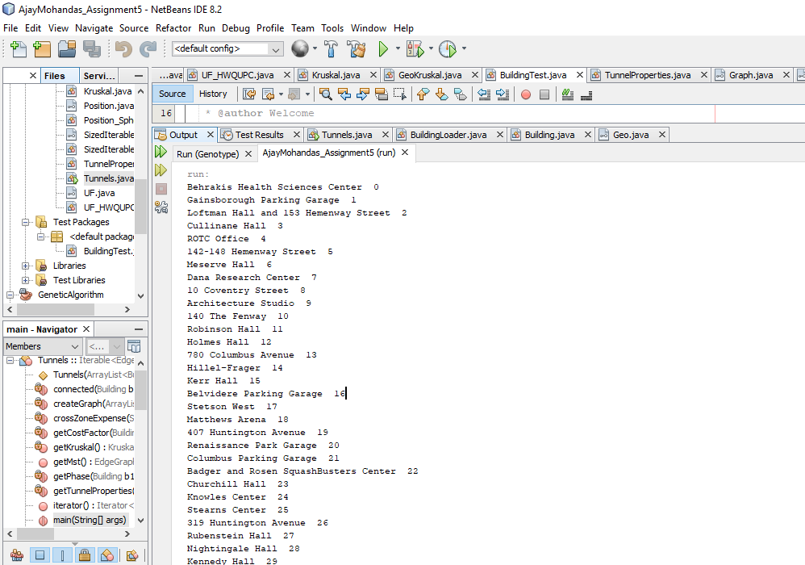

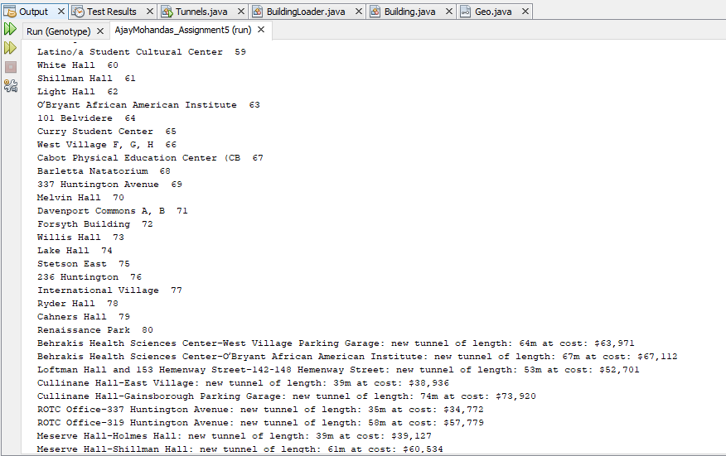

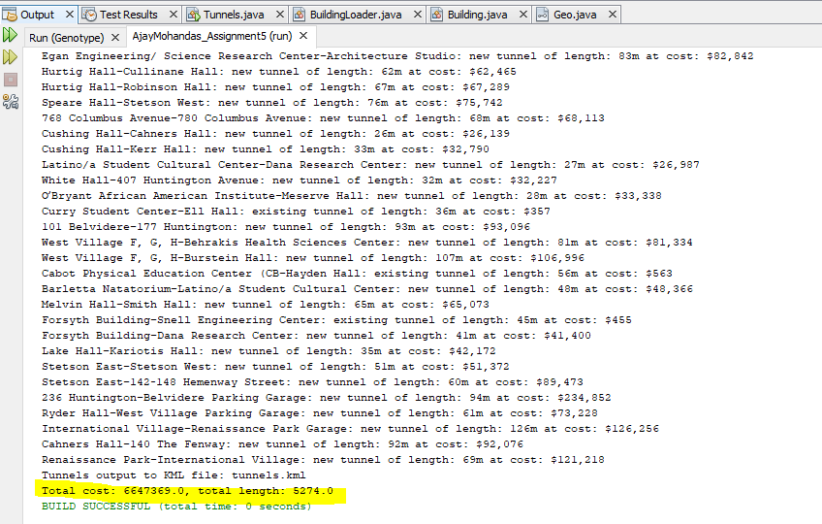

# Conclusion

Kruskal’s algorithm is a greedy algorithm of picking up smallest weight possible and prevents formation of cycle while building the minimum spanning tree. The order of growth for this algorithm using Union find and path compression is E Log*V where E is number of tunnels and V is number of buildings in this problem